**Boot Camp Day-2**

**Programe:1**

**import** java.util.Scanner;

**public** **class** Oranges {

**public** **static** **void** main(String[] args) {

Scanner sc=**new** Scanner(System.***in***);

**int** oranges;

**int** gross=0;

**int** aboveGross;

**int** dozens;

**int** extras;

System.***out***.print("Enter number of oranges: ");

oranges = sc.nextInt();

**if**(oranges!=0) {

gross = oranges / 144;

aboveGross = oranges % 144;

dozens = aboveGross / 12;

extras = aboveGross % 12;

System.***out***.println("Your number of oranges is "+gross+" gross,"+dozens+" dozen, and "+extras+".");

}

}

}

**Output:**

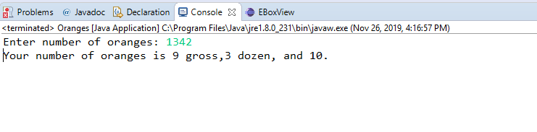

**Programe:2**

**import** java.util.Scanner;

**public** **class** Prime {

**public** **static** **void** main(String args[])

{

**int** num, i, count=0;

Scanner scan = **new** Scanner(System.***in***);

System.***out***.print("Input any integer: ");

num = scan.nextInt();

**for**(i=2; i<num; i++)

{

**if**(num%i == 0)

{

count++;

**break**;

}

}

**if**(count == 0)

{

System.***out***.print(num+"p");

}

**else**

{

System.***out***.println();

}

}

}

**Output:**

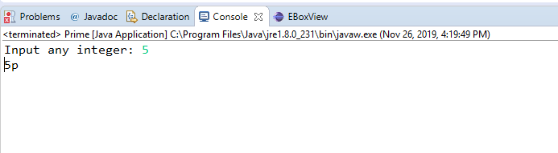

**Programe:3**

**Programe:4**

**Programe:5**

**package** Practice1;

**import** java.util.Arrays;

**import** java.util.HashSet;

**public** **class** Intersection

{

**public** **static** **void** main(String[] args)

{

Integer[] a = {10,4,5,8,6};

Integer[] b = {9,5,4,7,11};

HashSet<Integer> set = **new** HashSet<>();

set.addAll(Arrays.*asList*(a));

set.retainAll(Arrays.*asList*(b));

//System.out.println(set);

//convert to array

Integer[] intersection = {};

intersection = set.toArray(intersection);

System.***out***.println("c = "+Arrays.*toString*(intersection));

}

}

Output:

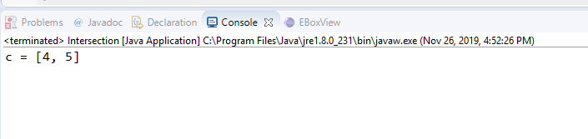

**Programe:6**

**package** Practice1;

**import** java.util.Scanner;

**public** **class** Sort {

**void** sort(**int** arr[])

{

**int** n = arr.length;

// One by one move boundary of unsorted sub array

**for** (**int** i = 0; i < n-1; i++)

{

// Find the minimum element in unsorted array

**int** min_idx = i;

**for** (**int** j = i+1; j < n; j++)

**if** (arr[j] < arr[min_idx])

min_idx = j;

// Swap the found minimum element with the first

// element

**int** temp = arr[min_idx];

arr[min_idx] = arr[i];

arr[i] = temp;

}

}

// Prints the array

**void** printArray(**int** arr[])

{

**int** n = arr.length;

**for** (**int** i=0; i<n; ++i)

System.***out***.print(arr[i]+" ");

System.***out***.println();

}

// Driver code to test above

**public** **static** **void** main(String args[])

{

Scanner sc = **new** Scanner(System.***in***);

Sort ob = **new** Sort();

**int** k = 6;

**int** arr[] = **new** **int**[k];

System.***out***.println("Input the array elements:");

**for**(**int** i = 0; i < k; i++)

{

arr[i] = sc.nextInt();

//{4,8,1,3,45,12};

}

ob.sort(arr);

System.***out***.println("Array elements after sorting:");

ob.printArray(arr);

}

}

**Output:**

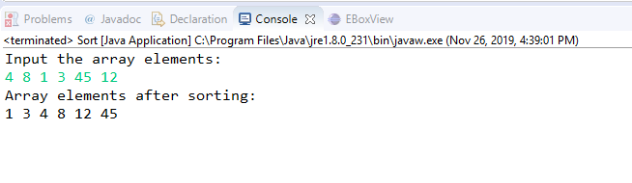

**Programe:7**

**package** Practice1;

**import** java.util.Scanner;

**import** java.util.Arrays;

**public** **class** RemoveDuplicate {

**public** **static** **void** main(String[] args) {

Scanner sc = **new** Scanner(System.***in***);

**int** num = 6;

**int**[] arr = **new** **int**[num];

**int**[] arrf = **new** **int**[num];

**for** (**int** a = 0; a < arr.length; a++)

{

arr[a] = sc.nextInt();

arrf[a] = 0;

}

**int**[] uni = **new** **int**[arr.length];

**int** n=0;

**for** (**int** b = 0; b < arr.length; b++) {

**if** (arrf[b] == 0) {

uni[n++] = arr[b];

**for** (**int** j = b+1; j < arr.length; j++)

{

**if** (arr[b] == arr[j]) {

arrf[j]=-1;

}

} } }

**for** (**int** i = 0; i < n; i++)

{

System.***out***.printf(""+uni[i]+",");

}

} }

**Output:**

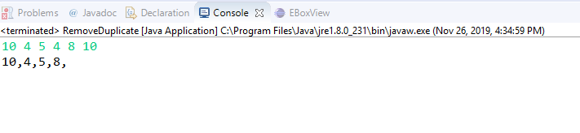

**Programe:8**

**package** Practice1;

**public** **class** MaxMin {

**public** **static** **void** main(String args[]){

**int** array[] = **new** **int**[]{10, 4, 5, 4, 8, 10};

**int** max = *getMax*(array);

**int** min = *getMin*(array);

System.***out***.println("Max = "+max+" & Min= "+min);

}

**public** **static** **int** getMax(**int**[] inputArray){

**int** maxValue = inputArray[0];

**for**(**int** i=1;i < inputArray.length;i++){

**if**(inputArray[i] > maxValue){

maxValue = inputArray[i];

}

}

**return** maxValue;

}

**public** **static** **int** getMin(**int**[] inputArray){

**int** minValue = inputArray[0];

**for**(**int** i=1;i<inputArray.length;i++){

**if**(inputArray[i] < minValue){

minValue = inputArray[i];

}

}

**return** minValue;

}

}

**Output:**

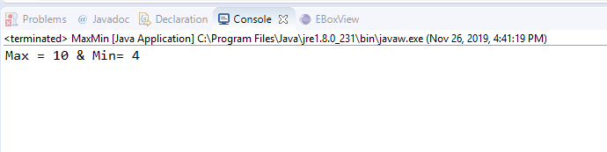

**Programe:9**

**package** Practice1;

**import** java.io.*;

**import** java.util.ArrayList;

**public** **class** Marks {

**public** **static** **void** main(String[] args)

{

// create an empty array list with an initial capacity

ArrayList<Integer> arrlist = **new** ArrayList<Integer>(6);

// use add() method to add elements in the list

arrlist.add(56);

arrlist.add(65);

arrlist.add(67);

arrlist.add(87);

arrlist.add(47);

// adding element 35 at fourth position

arrlist.add(2, 78);

// let us print all the elements available in list

**for** (Integer number : arrlist) {

System.***out***.print(""+number+",");

}

}

}

**Output:**

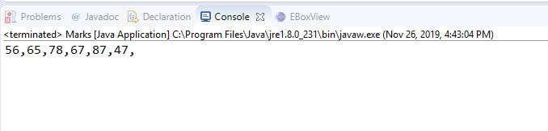

**Programe:10**

**package** Practice1;

**import** java.io.*;

**import** java.util.*;

**public** **class** Equal {

**public** **static** **boolean** areEqual(**int** arr1[], **int** arr2[])

{

**int** n = arr1.length;

**int** m = arr2.length;

**if** (n != m)

**return** **false**;

Arrays.*sort*(arr1);

Arrays.*sort*(arr2);

**for** (**int** i = 0; i < n; i++)

**if** (arr1[i] != arr2[i])

**return** **false**;

**return** **true**;

}

**public** **static** **void** main(String[] args)

{

**int** arr1[] = {2,5,7,1,2};

**int** arr2[] = {7,1,9,8,4};

**if** (*areEqual*(arr1, arr2))

System.***out***.println("Equal");

**else**

System.***out***.println("Not Equal");

}

}

**Output:**

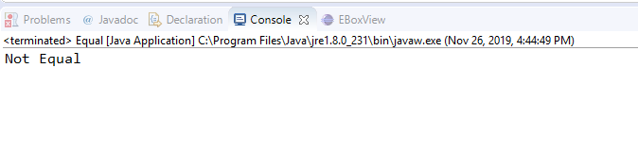

**Programe:11**

import java.util.Scanner;  
   
class Fact  
{  
public static void main(String args[])  
{  
int n,n1,n2,n3,fac=-1,fac1=1,fac2=1,fac3=-1,i;  
Scanner sc = new Scanner(System.in);  
n = sc.nextInt();  
n1 = sc.nextInt();  
n2 = sc.nextInt();  
n3 = sc.nextInt();  
  
for(i=1;i<=n;i++)  
fac*=i;  
  
 for(i=1;i<=n1;i++)  
 fac1*=i;  
  
for(i=1;i<=n2;i++)  
fac2*=i;  
for(i=1;i<=n3;i++)  
fac3*=i;  
  
  
System.out.println(fac);  
System.out.println(fac1);  
System.out.println(fac2);  
System.out.println(fac3);  
}}  
**Output:**

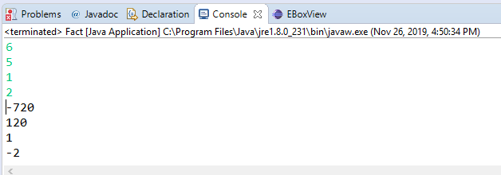

**Programe:12**

**package** Practice1;

**import** java.util.Scanner;

**public** **class** Triangle {

**public** **static** **void** main(String args[])

{

**int** a ,b ,c;

**int** sum;

String[] linevector;

String line;

Scanner sc=**new** Scanner(System.***in***);

line=sc.nextLine();

linevector=line.split(",");

a=Integer.*parseInt*(linevector[0]);

b=Integer.*parseInt*(linevector[1]);

c=Integer.*parseInt*(linevector[2]);

sum=a+b+c;

**if** (sum== 180)

System.***out***.print("Triangle");

**else**

System.***out***.print("Not a Triangle");

}

}

Output:

